

Software Engineering Department
Braude College of Engineering

Capstone Project - Phase A (61998)

Code Escape Together

26-1-D-16

Students:
Daniel Rozentsvaig - Daniel.Rozentsvaig@e.braude.ac.il
Elias Farah - Elias.Farah@e.braude.ac.il

Advisor: Dr. Sulamy Moshe - MosheSu@braude.ac.il

GitHub Repository: https://github.com/Luffyyy/Capstone-Project
Table of Contents
Abstract 3
1. Introduction 3
2. Related Work 4
3. Background 7
3.1. Visual Programming Language (VPL) 7
3.2. Game-Based Learning and Educational Escape Rooms 8
3.3. Peer-to-Peer (P2P) 8
3.4 Unity Engine 9
3.5 Mirror Networking 10
4 Expected Achievements 10
4.1 Outcomes 10
4.2 Unique Features 11
4.2.1 Co-op 11
4.2.2 Visual Programming 11
4.2.3 LAN Connection 11
4.3 Criteria for Success 11
5 The Process 12
5.1 Research – Game Development and the Unity Engine 12
5.2 Research – Visual Programming Languages (VPL) 12
5.3 Research - Multiplayer Networking Using Mirror 13
5.4 Methodology and Development Process 13
6 Product 14
6.1 Requirements 14
6.2 Architecture Overview 15
6.3 Scenes and Flow (Prototype) 15
6.4 Diagrams 19
6.4.1 Use Case 19
6.4.2 Activity 19
6.4.3 Sequence 20
7 Verification and Evaluation 20
7.1 Evaluation 20
7.2 Verification 21
8 References 22

Abstract
Programming may be a difficult subject to grasp at first, especially for teenagers when it’s introduced through abstract or text-heavy methods.
Traditional methods often fail to provide an engaging, collaborative environment where students can actively apply computational thinking. There is a lack of accessible programs that demonstrate real-time interaction between different components in a system.
Code Escape Together addresses these issues by creating a multi-device, cooperative escape-room game that teaches programming logic through visual, interactive tasks with the interaction being done via peer-to-peer connection between clients.
As the players traverse the various escape rooms, the puzzles become more challenging and encourage the players to think in an algorithmic way to escape the room.

Introduction
Code Escape Together is a 3D cooperative (Co-op) escape room game for two players that teaches the fundamentals of programming and algorithms through immersive and collaborative gameplay that requires both players to construct code using elementary building blocks to overcome in-game challenges.
The primary audience for the project is teenagers and beginner programmers who often find traditional, text-heavy programming courses too daunting and overwhelming, but still wish to learn more about programming. Code Escape Together provides a learning process through a fun, cooperative and engaging escape room game.
To ensure maximum accessibility, comfort and appeal, especially since Code Escape Together is primarily designed for smartphones, the method of “coding” utilizes visual programming style via logical building blocks. For example, setting variables, “if statements” and loops. This allows the player to focus on the code’s semantics (the meaning of the code) rather than syntactics (the way the code is written).
In Code Escape Together, the players must escape a room using coding logic to solve puzzles. As the game progresses, it will introduce new programming concepts that players must use to escape. For example, the game introduces the concept of “if statements” and then the players enter a room where that concept is needed.
Code Escape Together uses peer-to-peer (P2P) technology to communicate with each other. It features the main screen which acts as the host machine and the two smartphones connect to each other using it. The main screen displays the whole game while the smartphones allow controlling each character in the game and construct the code blocks that the characters will execute.
When a player executes a code, the code must be sent to the other player and the main screen, this showcases the idea of Internet of Things (IoT) and how devices interact with each other over the internet.
In true cooperative fashion, Code Escape Together encourages and sometimes outright requires the players to do actions together to escape the room, for example one player goes to an interactive button, presses it while the other player enters a room that opens thanks to the button and activates another button that was previously unreachable.
By combining visual programming, escape rooms, and cooperative gameplay, Code Escape Together aims to provide an innovative educational experience that bridges the gap between theoretical learning and practical learning.

Related Work
In the last few years, with the rise of AI tools, teenagers are becoming less interested in reading and exploring topics they are interested in on their own. They rely on AI tools to do their job for them; this is becoming an issue that may cause teenagers to not think for themselves and may reduce their ability to solve analytical problems.
Moreover, many students have issues with concentration when learning with traditional methods, such as presentations, books and thus show less interest in engaging in the lecture. This issue might lead the students to have fewer creative skills and thinking skills or lose the ability to show interest in most subjects in life which could be due to low attention spans.
Additionally, schools and academies started utilizing collaborative learning more rather than each student on their own. For example, coding laboratories in which two students must work together or a project in which three or more students must work together and coordinate.
Game-based Learning (GBL) is another modern approach to teaching that tries to tackle the issue of low attention spans. One paper [‎1] supports the use of gamification elements such as leaderboards, points and badges as effective method for increasing engagement levels in people another paper ‎[2] strongly recommends the use of storytelling elements to make the game more interesting and appealing. And ‎[3] mentions teachers trying Educational Escape Rooms with some success.
Visual programming languages, particularly block-based programming environments, are increasingly used in educational settings to support GBL and the development of computational thinking [‎4]. By replacing textual syntax with intuitive visual blocks, these environments enable learners to focus on core problem-solving processes such as logic, sequencing, and abstraction. When integrated with design thinking approaches, visual programming encourages creativity, iteration, and collaboration, allowing students to design and refine digital artifacts in a structured yet engaging manner. Research shows that such environments are especially effective for primary students, as they lower barriers while promoting active participation, teamwork, and innovative thinking, aligning well with modern, learner-centered instructional models.
Given the identified challenges of student disinterest and reliance of AI, the following papers present research backed solutions:
First example [‎5] showcases a randomized controlled trial examining the effectiveness of an educational virtual escape room in software engineering instruction, compared to traditional lecture methods. The study used a sample of 326 software engineering students to measure knowledge acquisition and students’ perceptions of game-based learning, using pre and post-tests. The main findings show that students in the escape room group showed significantly better knowledge acquisition as well as positive perceptions of the activity. The authors emphasize the need for further strong empirical evidence.
‎[6] presents Scottie Go! As an example of a modern teaching method that employs active learning to combat low engagement. Much like educational escape rooms, this tool moves beyond simple memorization by utilizing an interactive puzzle-based mobile game that requires students to apply knowledge creatively to solve problems. The game has a unique way of playing by requiring students to arrange cardboard coding tiles to essentially “write” code which then they must scan with a companion mobile app which then executes it. This approach pushes learners to grasp abstract concepts through active manipulation of blocks rather than passive reading, helping students that need deeper engagement with the game.
To tackle the issue of low attention span, Scottie Go! has story and reward elements that increase engagement. The game features a friendly alien named Scottie and the players need to help Scottie repair his spaceship and return home. It further gamifies the experience by awarding stars based on how efficient the code is encouraging players to optimize their solutions. This combination of storytelling and reward system creates a stimulating environment that encourages players to do more and keeps them entertained.
Another example [‎7] details a study that attempts to address the challenges of teaching programming, specifically motivation and visualization through an educational escape room. The authors wished to design a game that teaches fundamental programming concepts for K-12 students and the Makerspace movement (informal learning spaces). Their solution was a web-based educational escape room game Escape with Python. The game is a retro styled RPG that consists of 10 rooms that cover five core programming concepts: variables, sequences, conditions, iterations and functions. The prototype was tested by 12 teachers. The reception was positive; the teachers appreciated the retro pixel-art look of the game and the focus on logical thinking. They felt the game successfully taught the abstract concepts. For example, using a dog and cat to explain how to command a computer. Despite that, the teachers felt the game lacked clear instructions on the game controls and the difficulty curve was too high with the game jumping too quickly between types of challenges.
[‎8] presents a study on the effectiveness of a Collaborative Multiplayer Serious Game (MSG) designed to teach Computational Thinking (CT) and programming concepts to primary school students. The researchers address the challenges of making problem-solving skills engaging for the young and non-technical by integrating educational content into a competitive-based game. The game, named Online Robot City, is a digital adaptation of the same board game.
The game revolves around a 2D grid environment where players must move robots to collect resources such as wood and stone and complete construction missions. Movement and actions are controlled by cards representing specific programming concepts. The cards include sequential cards (basic movement) and conditional cards (logic cards). The game requires a minimum of four players divided into teams to encourage interaction. Additionally, the game includes a chat and the ability to exchange cards to help teammates.
The researchers conducted an experiment involving 12 elementary school students from a French school in Morocco, they used a 16-question pre-test and post-test, the key findings were that the study resulted in positive results in both learning outcomes and user engagement. The game had a positive effect on students’ test scores. Out of the participating teams, four improved their scores, one remained the same and one decreased slightly.
Aside from academic solutions, there are commercial cooperative escape room games, one example is Escape Simulator [‎12], it is a first person escape room video game developed by Pine Studio and released in 2021. It is based on real-life escape rooms where objects can be interacted with and broken. The player must figure out how to escape the room by solving puzzles. It can be played cooperatively with up to 10 players. The game also has a tool to create your own rooms with more than 3000 rooms made for it. The game had good reception with up to 2 million sales by May 2022.
Considering all the above, the papers showcase promising solutions to the problem, but the solutions usually focus on groups of students or a single student. Some don’t use a visual programming language which is where Code Escape Together fills the gap, since Code Escape Together requires two players to work together, coordination is more important. Additionally, the use of AI is lessened with the fact that the two players must communicate in real-time and explain concepts to each other rather than let AI do all the work. This method also catches the attention of the students and keeps it for a longer period.

Background

Visual Programming Language (VPL)
Visual Programming Language (VPL) [‎13] is any programming language that uses predefined code blocks instead of text-based programming languages such as C or C++. Most programming languages today are text-based, for example if you want to print some text, you must write the complete text using syntax and functions of that language, however in VPLs the writing is replaced by placing special component blocks that can be joined logically to perform the task.
VPLs let the user think in a logical manner compared to regular languages, the programmer must think how they can explain the program to the computer.
Example of Visual Programming Languages:
- Scratch [‎14] – Allows users to create stories, games and animations without writing any lines of code.
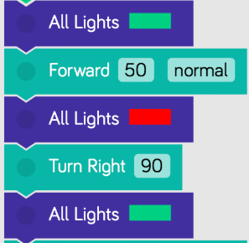
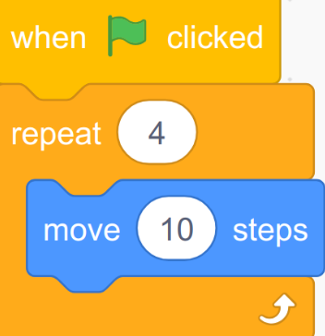
- Blockly [‎15] – Used to create block-based programming languages and editors, it can also generate code to Javascript, Python and more.
Figure 1 - Scratch
Figure 2 - Blockly

Game-Based Learning and Educational Escape Rooms
Game-based learning [‎9] is the borrowing of gaming aspects and applying them to real-life educational settings to engage learners. The motivational psychology involved in game-based learning allows students to engage with the materials in a playful and dynamic way.
Such games can include competition with points and leaderboards or other incentives, with such concepts becoming more popular in higher education and libraries to increase engagement in learning.
Escape rooms [‎10] are live action team-based games in which players must complete challenges to complete a certain mission. Originally, the nature of the mission was essentially escaping from the room, however now the missions may differ. Examples include murder mystery, breaking into a vault and more.
With the popularity of escape rooms outside the classroom, enthusiastic teachers got inspired to try adapting this activity for education in schools and academies. They have shown to successfully create an active learning environment with vast majority of students reporting enjoying the activity and showing higher engagement levels compared to regular classes.
Despite the apparent success, educational escape rooms as a standalone method for teaching new content is not proven with measured knowledge gain. They are good for engagement levels, but less for teaching theoretical information on the spot.

Peer-to-Peer (P2P)
Peer-to-peer [‎16] is a communication model that is known for its fast message forwarding between two clients. P2P deals with network structures where each device is both the client and the server while having a small number of devices.
Code Escape Together uses this model since it is easy to set up compared to a traditional client-server connection. Additionally, P2P is a very fitting and fast method for communicating between two nearby phones and a computer.

Advantages of P2P:
- Easy to Maintain – Each node is independent of the other.
- Less Costly – No need for an external server that costs money.
Disadvantages of P2P:
- Less Secure – It becomes more difficult to maintain the security of the network.
- Slow Performance – Since each computer is accessed by other computers, this may slow down the performance.

Unity Engine
Unity [‎17] is a game engine developed by Unity Technologies, being first announced and released in June 2005 as a Mac OS X only game engine. As time went on, support has been added to more platforms such as Windows, Linux, phones and gaming consoles.
Today, the engine is quite popular especially on Android and iOS for mobile game development. It is considered easy to use for beginner developers and is popular in the indie game sphere.
Main Features:
- Game Development: Unity gives developers the ability to create games and experiences in both 2D and 3D.
- Cross Platform Support: Unity supports many platforms such as desktops, gaming consoles, mobile phones, VR and XR.
- Scripting: Unity uses C# language as its scripting language which is relatively easy to grasp for new programmers.
- Rendering: Unity supports many modes for rendering, allowing developers to fine-tune games to their liking.
- Asset Store: Developers can create user-generated assets to sell as a resource of revenue.
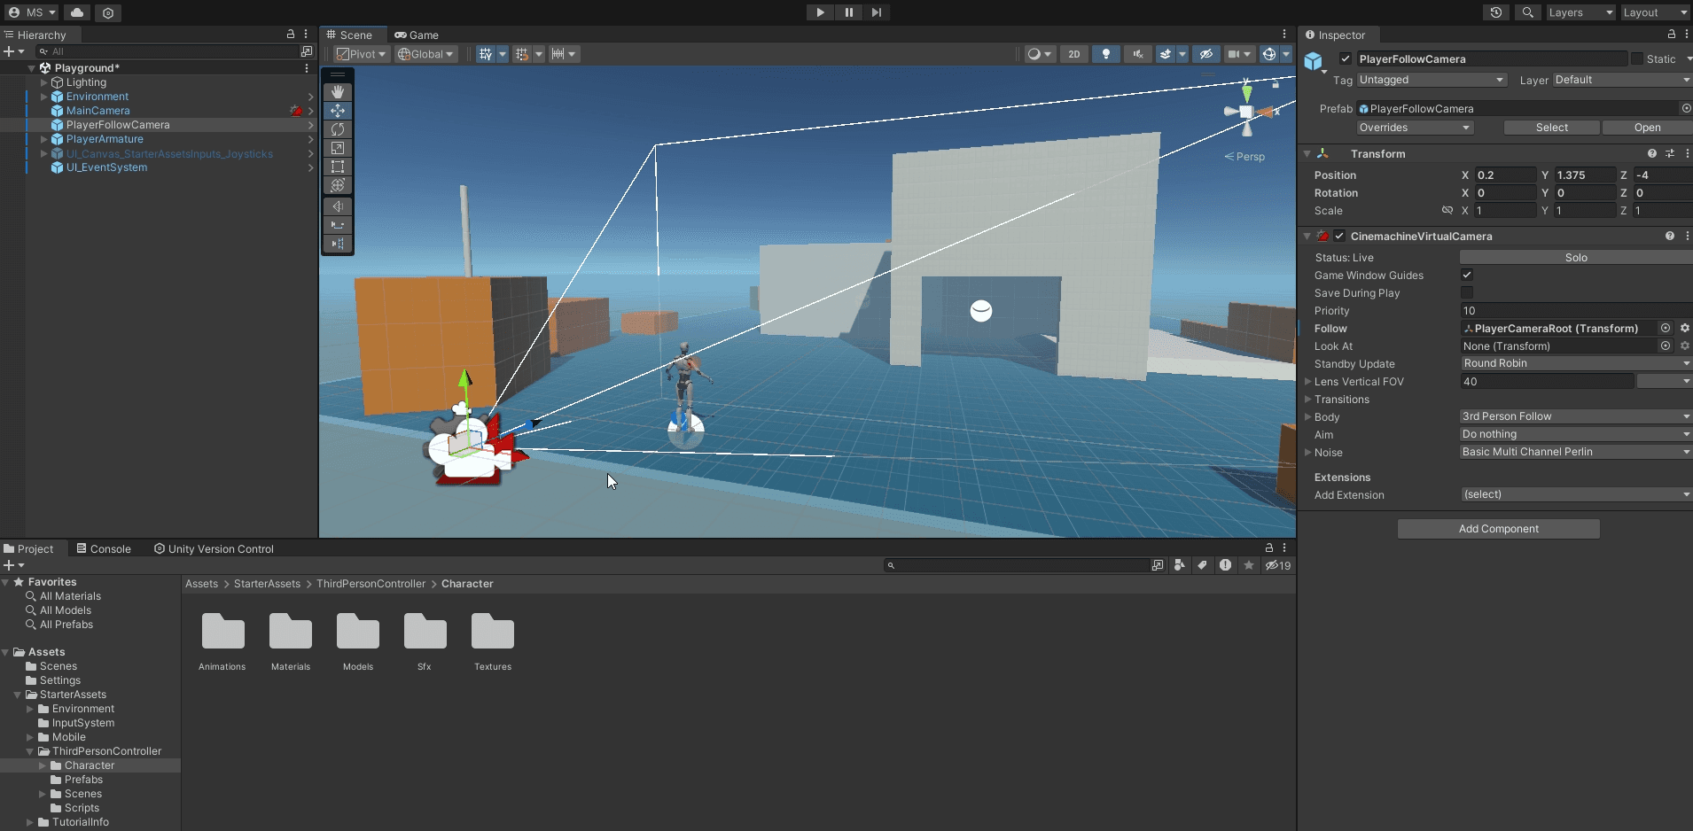
Figure 3 Unity Engine Editor

Mirror Networking
Mirror [‎18] is a high-level networking framework that is used for multiplayer applications in the Unity game engine. It Allows the developer to manage the network connections, message exchange and state synchronization since it is an abstract framework. This allows the developer to focus on gameplay logic rather than low level connection algorithms and details. Mirror is mostly used for small to medium scale multiplayer games due to its flexibility and ease of integration.
The network architecture that Mirror is based on is client-server with an authoritative server. In most cases, particularly in small multiplayer games, the players or one of the players hosts one of the devices as a server. This removes the need for external and dedicated servers, while maintaining centralized control over the game state. All communication between players is routed through the host, ensuring consistency and reducing the risk of desynchronization.
Mirror uses state mechanisms such as synchronized variables and procedure calls to synchronize the shared game state. This allows efficiency of player propagation and game events across all connected clients. In addition, by enforcing server authority, Mirror tackles the issue of conflicting updates and simplifies validation of player actions.
Code Escape Together employs a host-based networking approach where the computer manages communication over a local network to manage communication between two smartphones. While not a fully decentralized peer-to-peer system, this uses P2P characteristics since Code Escape Together does not require an external dedicated server.

Expected Achievements

Outcomes
Our goal is to teach the basics of programming and computer science to teenagers and beginner programmers in a way that is both fun and educational.
To make the game accessible, it uses a visual programming language that allows players to construct code in the game using their smartphones, lowering the entry barrier for beginners.
Additionally, the game is designed to be easily set up and played almost anywhere, with the only requirement being a computer, two smartphones and a local network.
Finally, we believe that the cooperative nature will add to the fun of the game while improving engagement and long-term retention of the material.

Unique Features

Co-op
Code Escape together features co-op gameplay that encourages the two players to think together and communicate while trying to bypass a challenging level. Most of Code Escape Together’s levels are designed in a way that forces the players to play together because we believe that teamwork is essential for learning since according to researchers, it has been shown that learning in a group is much more beneficial than doing it alone [‎11].

Visual Programming
Code Escape Together uses visual programming to make the learning process easier to perceive because it is not text heavy and does not focus on syntax. Visual programming is effective for beginners essentially because it lowers the barrier to programming and assists the learner to focus on logic and grasp the core of code and programming.

LAN Connection
The project will utilize the Mirror library [‎18] to enable LAN connectivity, removing the need for an external server and a constant internet connection, you will only need a home network and three devices. The use of a local network will also improve latency since all devices are next to each other.

Criteria for Success
- Accessibility - The game is accessible and easy to pick up for teenagers and should not require past knowledge.
- Performance - The game runs smoothly on a wide range of smartphones without noticeable latency or crashes.
- Visual Programming Usability - The visual programming language is easy to use without confusing elements baked into it.
- Network Performance - The connection is fast and responsive.
- Cooperative Gameplay - The game encourages cooperative gameplay.
- User Interface usability - The user interface is intuitive and consistent.
- Learning Effectiveness – The game successfully teaches programming concepts and the players can apply said knowledge in the game.
- Progressive Difficulty – The game introduces programming concepts gradually, ensuring challenges build upon the knowledge.

The Process

Research – Game Development and the Unity Engine
The learning process of unity began with learning the basics of Unity, we used Unity basic tutorials “Unity Essentials” which is unity’s starter guide for beginners to get going and started to gain knowledge about the platform and game development in general. Sometimes these tutorials did not cover additional explanations and examples, so we had to use the help of advanced tutorials videos on YouTube and used AI tools to help us achieve solutions for challenges we gave ourselves. For the first phase of the project, we focus on the most basic part of the game such as the peer-to-peer connection and basic level to showcase the idea before we delve into the second phase to develop a fully fledged game.

Research – Visual Programming Languages (VPL)
Since the game uses a visual programming language as the main coding language for controlling it, we researched VPLs, specifically, the challenges of such languages and how to design them.
One of the main challenges of VPLs is scalability, as programs grow larger, the number of blocks can become difficult to manage and understand. Additionally, visual representations require more screen space compared to text-based code, which may limit the complexity of programs that can be comfortably created.
Another challenge is abstraction, as much of the execution logic is hidden from the user, which can make debugging and performance understanding more difficult. Despite these challenges, VPLs offer significant advantages in terms of usability and learning.
Both Scratch [‎14] and Blockly [‎15] are designed around clear visual patterns that emphasize logic flow rather than syntax. Blocks can fit together only in specific ways, reducing the possibility of syntactic errors and guiding users toward correct program structure. We looked at these languages to see how typical VPLs look like and we noticed a pattern that both have simple English on each block to ease the understanding and do most of the work behind the scenes. To be more specific, the block holds the name of the action that the user can pick and choose to execute such as “Move 90” and more.
A common pattern observed in both languages is the requirement for a clear execution flow, typically starting from a designated start or event block and continuing in a top-to-bottom chronological order. This structure makes the program flow easy to follow and helps users mentally simulate the execution of the code.
While Scratch focuses on creativity and engagement through a closed, beginner-friendly environment, Blockly provides a more flexible and extensible framework that can be adapted to different applications and can generate text-based code. The shared design patterns between these languages demonstrate established best practices in VPL design.
The insights gained from researching Scratch and Blockly directly influenced the design of the visual programming system used in this game. By adopting similar block patterns, descriptions, and execution order, the system aims to provide an intuitive coding experience while maintaining logical clarity and consistency and allows players to focus on problem-solving and game mechanics rather than programming syntax.

Research - Multiplayer Networking Using Mirror
At the start of the development process, implementing P2P networking was a strong idea since it naturally allows devices to communicate with each other directly without a server, but as we began to experiment with the early development of Code Escape Together, we realized that pure P2P might not be our solution and is not the best networking approach to use for our requirements. We realized that we needed a host to act as a server and as a client in addition to the requirement of ensuring smooth state updates for the whole game.
With that, we discovered the Mirror library that mainly focuses on client-server architecture, however we still maintain the P2P characteristics since the server is not external and is simply a computer acting as a middleman between the two devices in a local network.
We experimented with a prototype project utilizing Mirror and attempted to communicate between the computer and two smartphones with success which prompted us to decide to go with the Mirror library for the project.

Methodology and Development Process
For the development of the project, we will use the Agile methodology which is flexible and allows us to manage the project in sprints and iterating features until the project is complete. In each sprint, we’ll discuss the changes and issues together and what is left to be developed.

The development will mainly revolve around the following stages:
- Building the base of the project.
- Implement Mirror networking.
- Designing the menus of the game.
- Implement the VPL system.
- Making the player system.
- Building the first proof of concept level, including finding or making appropriate 3D models.
- Implement the puzzle/escape room system.
- Implement the scoring and badges system.
With the main development stages, from time to time we will collect user feedback to better shape the game into a project that will be fun, engaging and achieve its goal of helping teenagers and novice programmers better understand programming and algorithms.

Product

Requirements
Functional:
The game allows placing visual programming blocks.
The game displays guidance dialogs.
The game allows connecting to a host machine.
The game allows the player to control the game through the smartphone.
The game tracks players’ progress and saves it locally.
The game allows achievements.
The game allows creating lobbies for playing.
The game allows interacting with the world.
The game allows repeating levels.
The game allows changing settings.

Non-functional Requirements:
Smooth performance with at least 60 fps on most current smartphones or 30 fps for battery preserving.
Accompany gameplay with mood fitting music.
Sound effects to increase engagement with the game.
The computer acts as a host machine, only displaying the game. The two smartphones act as controllers for the two players.
Pop out badges mid game to show new achievement unlocked
Support different resolutions.
Controls are placed in a comfortable position as most mobile games do.

Architecture Overview
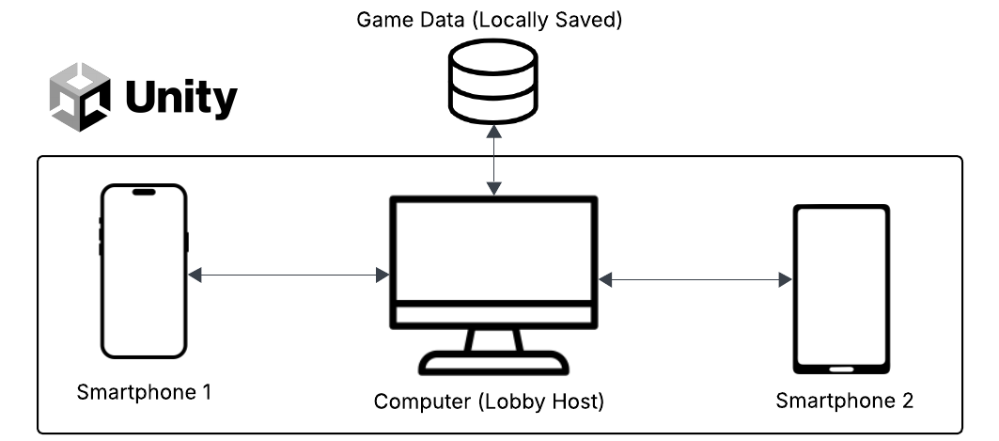

Scenes and Flow (Prototype)
Computer Main Menu:
The computer’s purpose in the game is to host and display the game, allowing the users to play together on a server. With that the only meaningful button will be the host game as seen in the figure (4).
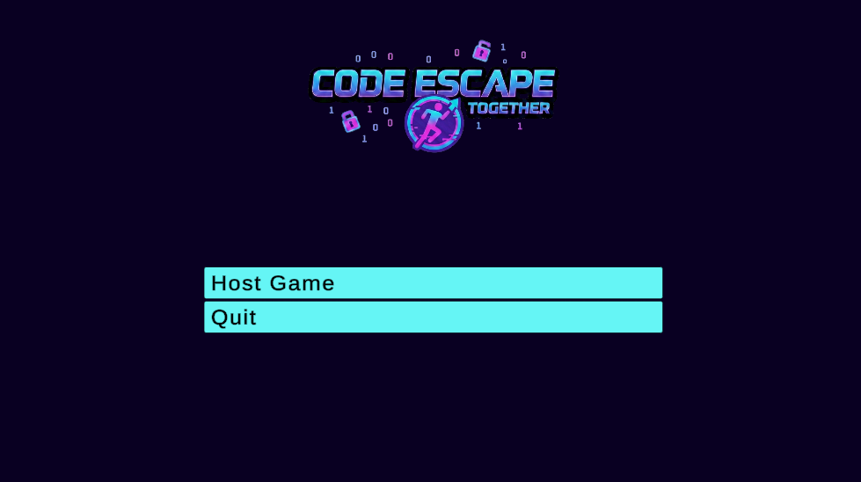
Figure 4 - Computer Main Menu
Phone Main Menu Screen:
The phones need a server to connect to, as such their main menu will contain a button named “Look for Games” that will display all discovered servers on the local network as seen in figure (5).
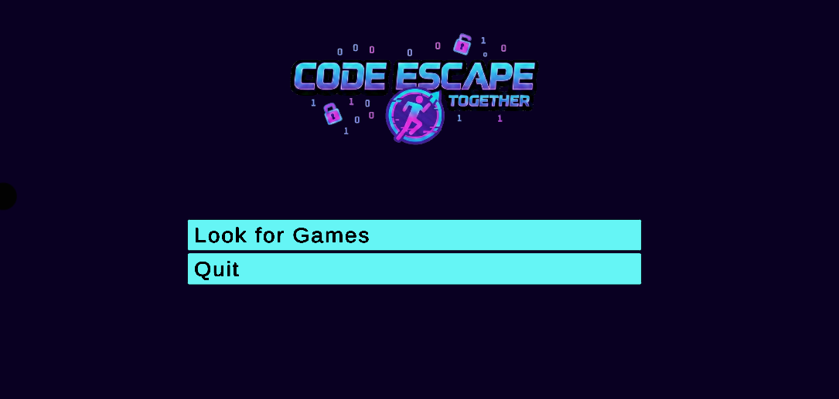
Figure 5 - Phone Main Menu Screen
Host Game:
To host a server (figure 6), a name for the server is needed, allowing the players to identify the server they want to connect to.
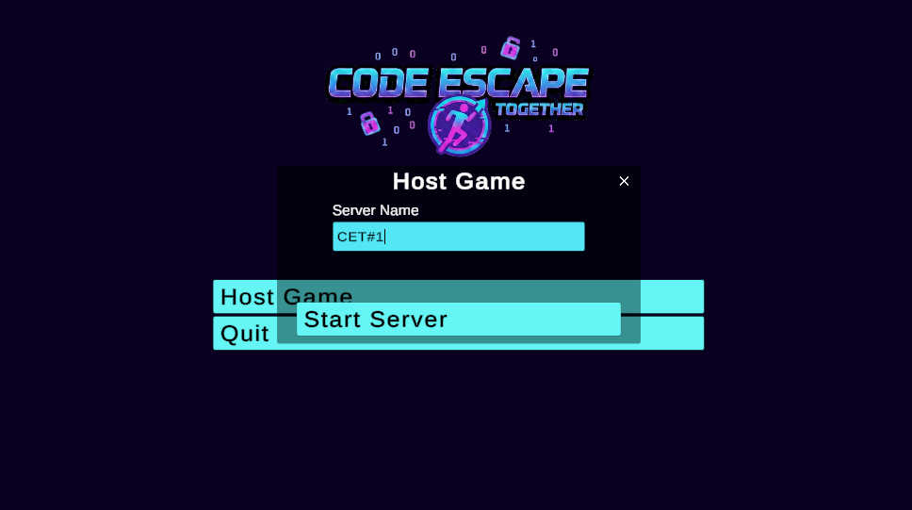
Figure 6 - Host Game Dialog

Join Game:
Available servers will be displayed when a player wants to join a game.
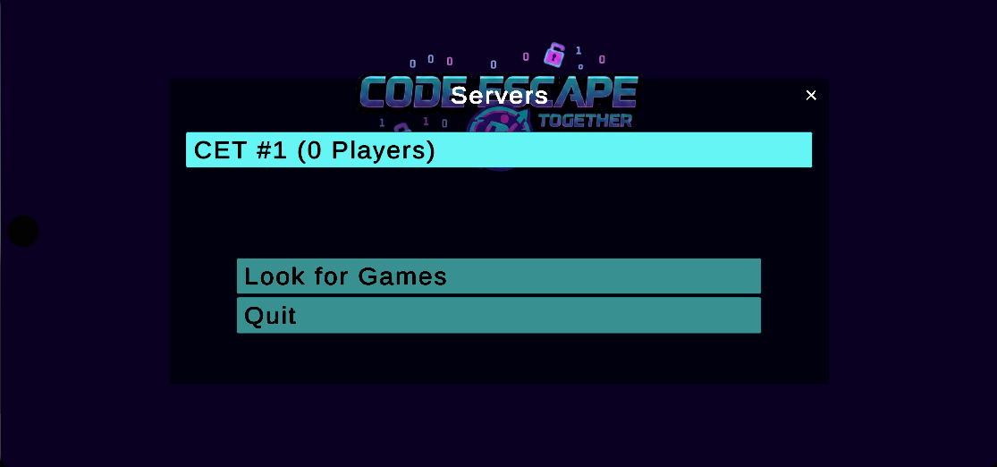
Figure 7 - Available ServersJoin Game Dialog
Phone block placement screen:
Upon solving a challenge, the VPL screen (figure 8) will appear, allowing the player to
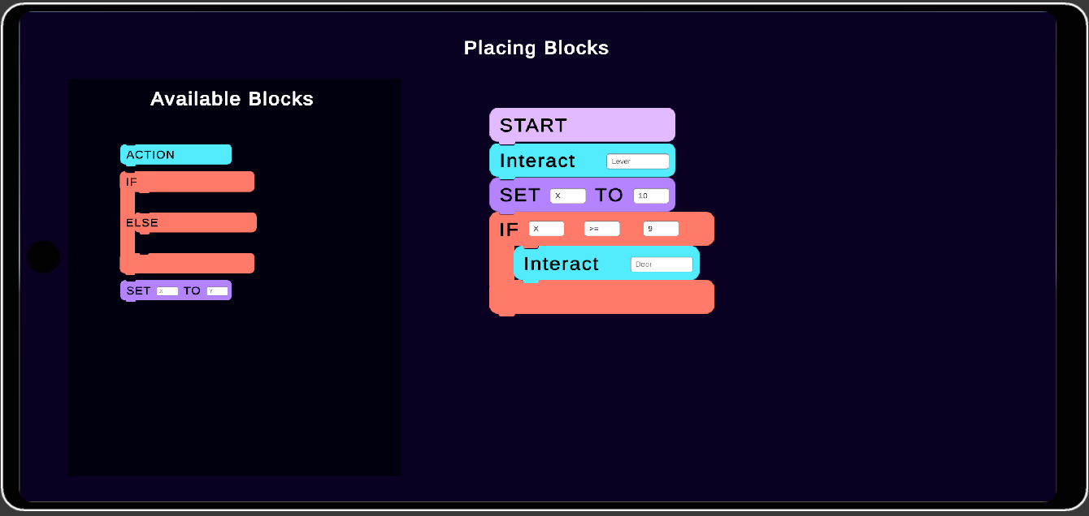
Figure 8 - Block placement screenVPL Mode

Co-op Flow:
Two players must cooperate to pass a level. One player does one task (open door), the second player does another task to successfully pass the level (disable traps) as seen in figure (9).
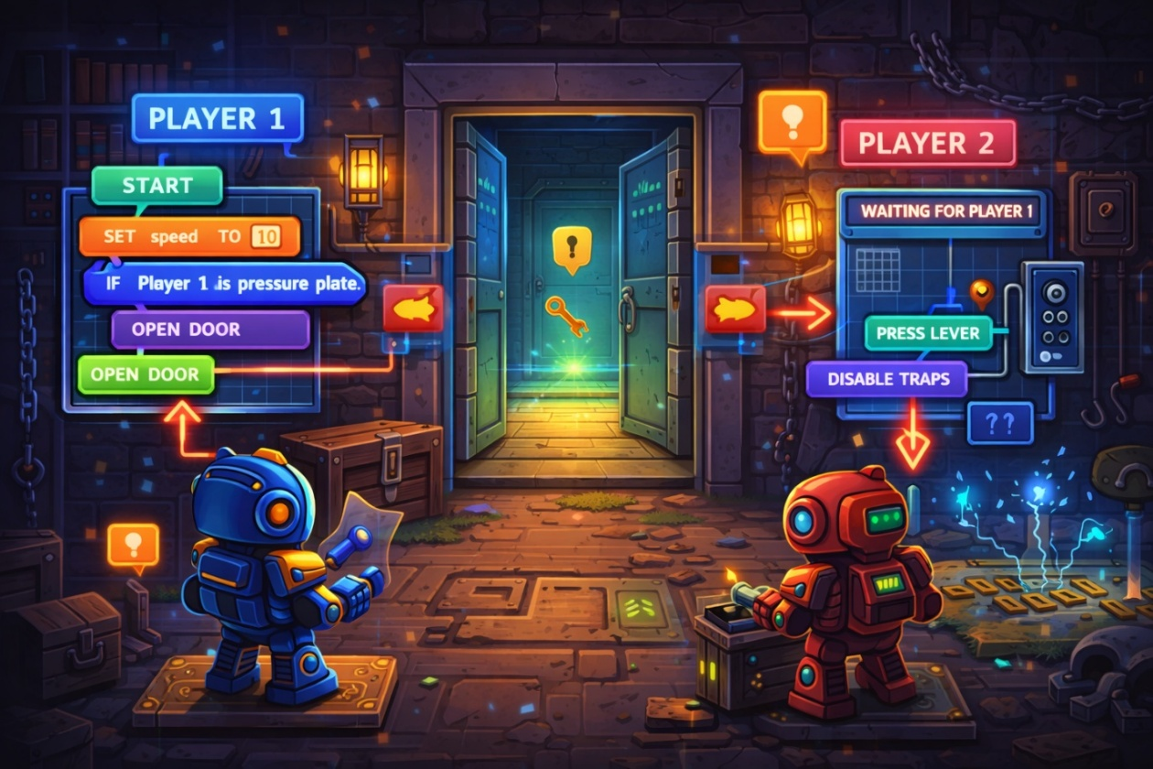
Figure 9 - Co-op Flow

Diagrams

Use Case
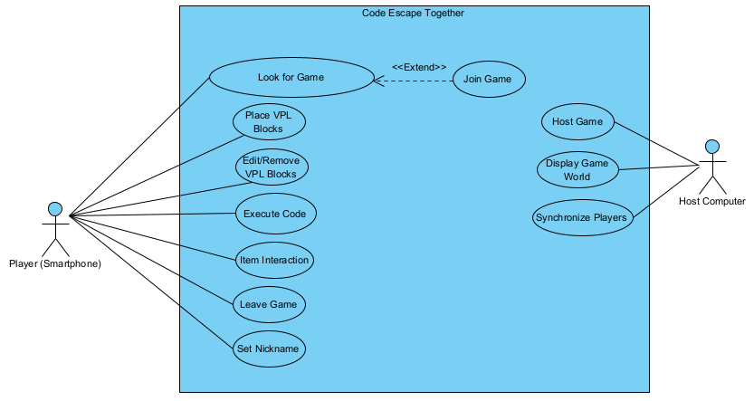

Activity
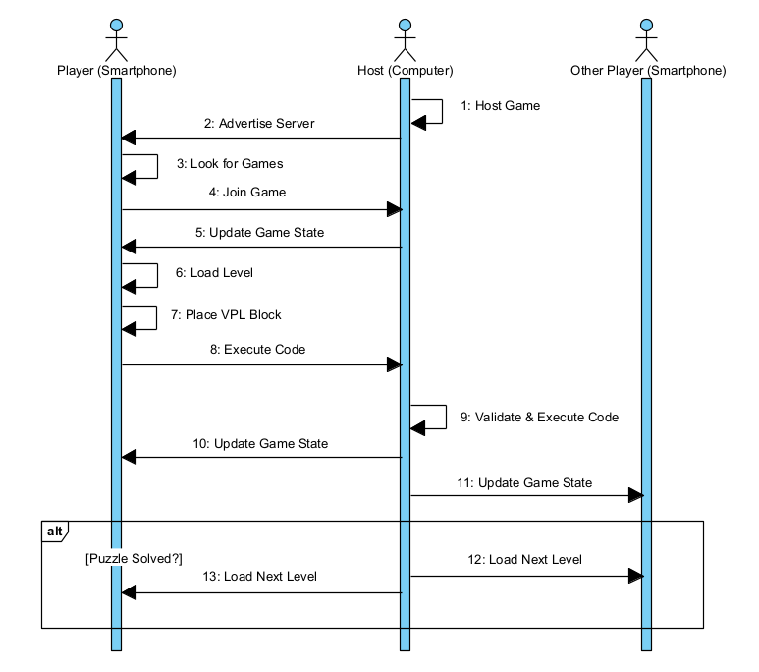

Sequence
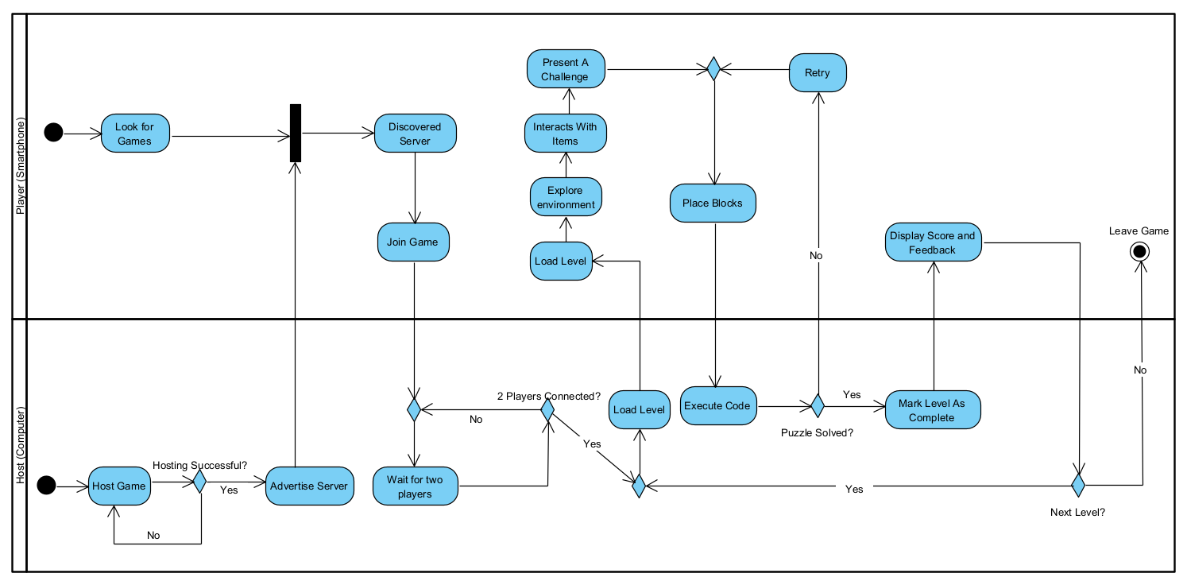

Verification and Evaluation

Evaluation
The following evaluation will dive into the system’s criteria and overall performance. Testing will be conducted in a local network environment using multiple devices, with an emphasis on practical behavior and user experience.
Accessibility – The system’s accessibility will be assessed by its ease of use for players with no programming background. The readable, constrained VPL blocks, together with local network multiplayer, are expected to support intuitive interaction and reduce barriers for beginners.
Performance – Once Mirror networking is implemented, we will test performance by measuring memory usage, average FPS, CPU usage as the game is expected to operate smoothly during testing, maintaining a stable frame rate and responsive interactions. No noticeable delays are expected between player actions and their effect in the game.
Visual Programming Usability – We will ensure VPL blocks use plain English to clearly describe their functionality and will contain only essential information for each action. In addition, block connections will be constrained to valid configurations, as illustrated in Figure 1 and Figure 2, to support ease of use and reduce user errors.
Cooperative Gameplay – In the design phase of each room’s level we will ensure that players cannot progress individually, requiring cooperation between the two players.
User Interface Usability – The game’s interface will provide clear navigation, consistent layouts, and immediate feedback for user actions, supporting an intuitive and engaging experience for players. We will monitor how the average player uses the UI so we can improve the user experience.
Progressive Difficulty – Levels will increase in complexity, gradually introducing more advanced programming concepts. Despite that, each level will be designed to maintain low cognitive load, keep gameplay engaging, and allow players to complete tasks without relying on external resources and to ensure that things are fair, we will collect feedback for the gameplay and difficulty.

Verification
Unity’s Unity Test Framework (UTF) and Unity Test Runner will be employed to verify both edit mode and play mode behavior. Tests will check script functionality, block execution, and multiplayer interactions to ensure correct operation during gameplay.
The programming language which will be used to develop Code Escape Together C# supports unit and integration testing to verify the correctness of code. UTF allows to implement these tests within gameplay, mechanics and multiplayer interactions to ensure a reliable and maintainable development environment.
Test # | Module | Tested Functions | Expected Result
1 | Mirror Network | Look For Game | Display hosts list
2 | Mirror Network | Join Game | Successfully join the server
3 | Unity Application | Place VPL Blocks | VPL blocks displayed on screen
4 | Unity Application | Edit/Remove VPL Blocks | Change or remove VPL blocks
5 | Mirror Network | Execute Code | Execute code if structure is correct
6 | Unity Application | Item Interaction | Display a prompt for interaction and perform interact
7 | Unity Application | Leave Game | Game closed
8 | Unity Application | Set Nickname | Display a label to enter a username
9 | Mirror Network | Host Game | Server is online
10 | Unity Application | Display Game World | Load the game and display it on screen
11 | Mirror Network | Synchronize Players | The player can see how another player behaves in real time

References
- Huang, B., & Hew, K. F. (2015, November). Do points, badges and leaderboard increase learning and activity: A quasi-experiment on the effects of gamification. In International Conference on Computers in Education.
- Giakalaras, M. M. (2016). Gamification and storytelling. Univ. Aegean, 8, 1-7.
- Veldkamp, A., Van De Grint, L., Knippels, M. C. P., & Van Joolingen, W. R. (2020). Escape education: A systematic review on escape rooms in education. Educational Research Review, 31, 100364.
- Wanglang, C., Sraubon, K., & Piriyasurawong, P. (2024). Combining Game-Based Learning with Design Thinking Using Block-Based Programming to Enhance Computational Thinking and Creative Game for Primary Students. Higher Education Studies, 14(2), 137-147.
- Gordillo, A., & López-Fernández, D. (2024). Are educational escape rooms more effective than traditional lectures for teaching software engineering? A randomized controlled trial. IEEE transactions on education, 67(5), 660-668.
- Videnovik, M., & Trajkovik, V. (2018). Using Scottie Go! as Game Based Learning Tool for Computational Thinking Course. In ICERI2018 Proceedings (pp. 1337-1344). IATED.
- Humble, N., Mozelius, P., & Sällvin, L. (2021, September). You can’t escape learning, but maybe you can get out of the room!-Game-based learning for programming education. In Proceedings of the European Conference on Games-based Learning (pp. 361-369).
- Wynn, A., Wang, J., Han, R., & Hsu, T. C. (2023, September). Multiplayer serious games supporting programming learning. In European Conference on Games Based Learning (Vol. 17, No. 1, pp. 721-729). Academic Conferences International Limited.
- Pho, A., & Dinscore, A. (2015). Game-based learning. Tips and trends, 2, 1-5.
- Veldkamp, A., Van De Grint, L., Knippels, M. C. P., & Van Joolingen, W. R. (2020). Escape education: A systematic review on escape rooms in education. Educational Research Review, 31, 100364.
- Flaherty, H. B. (2022). Using collaborative group learning principles to foster community in online classrooms. Journal of Teaching in Social Work, 42(1), 31-44.
- Escape Simulator - Wikipedia. https://en.wikipedia.org/wiki/Escape_Simulator
- Mahendra. Introduction to Visual Programming Language - GeeksforGeeks. https://www.geeksforgeeks.org/software-engineering/introduction-to-visual-programming-language/
- Scratch (programming language) - Wikipedia. https://en.wikipedia.org/wiki/Scratch_(programming_language)
- Blockly – Wikipedia. https://en.wikipedia.org/wiki/Blockly
- Mathur Anukruti. What is P2P (Peer-to-Peer Process)? - GeeksforGeeks. https://www.geeksforgeeks.org/computer-networks/what-is-p2p-peer-to-peer-process/
- Unity (game engine) - Wikipedia. https://en.wikipedia.org/wiki/Unity_(game_engine)
- Mirror Networking. https://mirror-networking.gitbook.io/docs/manual/general

